Season’s Greetings,

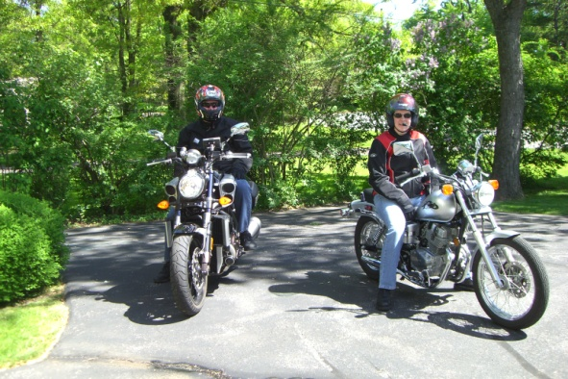
It’s Mr. Max (Rob’s new motorcycle) here to cruise you through the events of 2009. Rob sold me to Ann as, “wouldn’t it be cool to own a totally redesigned version of my last two motorcycles”? Girl translation….limited edition and high price tag. Whoever said women like to accessorize, hasn’t met Rob. I got a mini keg (auxiliary gas tank) for my drinking problem, a GPS and forward foot pegs. It’s all about comfort on the Sunday afternoon rides, you know!
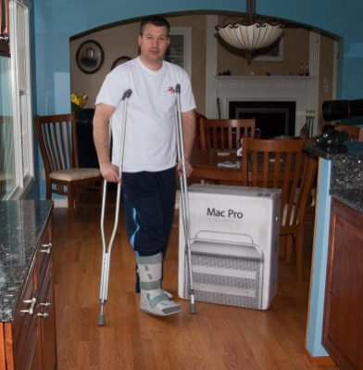
Because it wasn’t riding season yet, Rob and Ann abandoned me at the dealership to go skiing with friends in Vermont. Words Ann should never hear from Rob over the phone, “I’m hurt and they’re taking me on the sled to the first aid station”; started four months of recovery from a broken ankle. You should never ask yourself, “what else could go wrong”? After returning from one of Rob’s doctor visits they discovered both hot water heaters were leaking and the phone line was dead. Let’s not forget that the roof leaked again causing a section of the kitchen ceiling to collapse. All have since been repaired along with a work shelf added in the laundry room.
Seeing that Rob was somewhat “grounded” (airplane speak, apparently) he sold his 11 year old car and 18 year old motorcycle on eBay and bought a Mac. Since Rob was on a roll with “sit down” activities, he talked Ann into taking a gun class. The vigilante “loons” in the CCW class were a bit much for her.

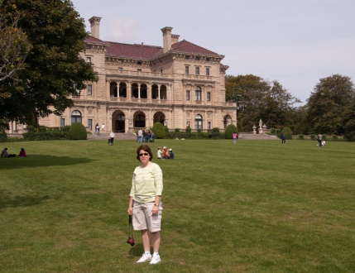
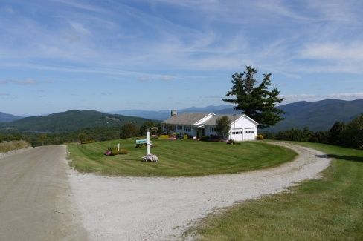
Rob inherited Ann’s Lexus and they bought her the new RX, which even has a mouse! To christen the car they took a weeklong trip to Rhode Island and Vermont (don’t worry, this trip didn’t involve skiing). They toured the mansions in Newport and stayed with Rob’s mother in Danby. Rob was anxious to get back in Tweety, so off they went to Sun-N-Fun, OshKosh and IRCHA. The doctor made the mistake of telling Rob that physical therapy was optional; hmmm…what do you think Rob did? I guess he thought all of the trade show walking was enough, yikes!
Usually people are more stressed when they quit their job, but not Ann. She was excited to have free time for golf, motorcycle riding and “girls only” weekends with Donna (sister) and Janet (sister-in-law). The biggest weekend found them in Albany for a fireman’s conference; at which Janet received a lifetime achievement award.
The story has tired me out, so I’m happy to be in the hangar for my winter rest.

We hope this finds you happy, healthy and looking forward to 2010!

