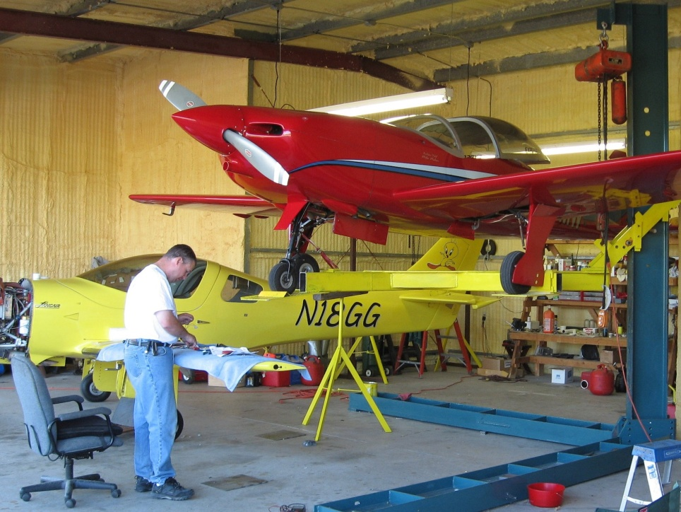
Season’s Greetings,
It’s Tweety (Rob’s airplane) here to give you a fly-by of Rob and Ann’s past year. After several days of Ann smelling gas, Rob finally admitted it wasn’t the burritos and they should call their favorite plumber. It turns out staying at the Marriott for two nights while your natural gas leak is being fixed, isn’t such a bad thing.
Since staying at a hotel is fun, Ann suggested she and her siblings go to the annual ice carnival a few miles from their home town. Personally I don’t like to be cold, but they did enjoy the frying-pan-toss contest and fireworks display. Of course Rob and I didn’t want to be left out of the traveling game, so we made our annual pilgrimages to Sun-n-Fun and OshKosh. We had fun catching up with our respective buddies even though my visits were relegated to the parking area. Rob made a lot of his treks with his pal Mike Mahar. Mike introduced me to his latest creation, Woody, who became my new hangar mate.
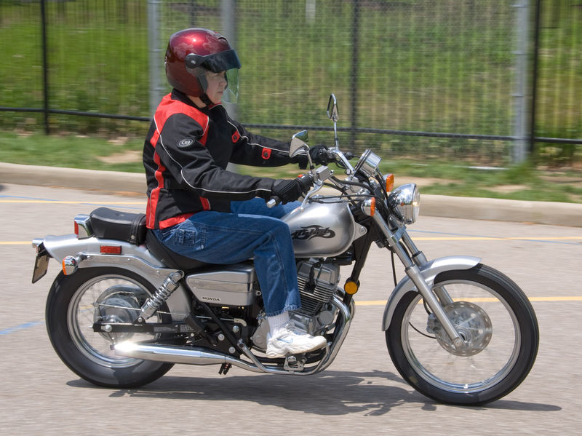
If I wasn’t enough of a vice, Ann decided to start her mid-life crisis early and bought a motorcycle! To stress Rob even more, she coerced him into participating in the local motorcycle safety course. Ann didn’t warm up to the instructor as much as Rob did, but then again I guess us arrogant guys need to stick together. Of course, with any new hobby comes a host of accessories. As some of you know, Ann isn’t as directionally savvy as I, so Rob found a GPS that works well. Once that was hanging from the handlebar, there was no stopping the number of trips to the store to buy a motorcycle cover, several theories of hand grips and a cargo net.
In her quest to continue the mid-life crisis and much to Rob’s dismay, Ann got a second tattoo. The “defacing” (Rob’s words, not mine) took place with the joint participation of her sister and sister-in-law. They were cohorts in a few “girls only” weekends this year, one of which took them to the beach in South Carolina.
After a few relaxing vacations, Rob and Ann decided it was time to tackle yet another house project; this time it was the driveway. Since the driveway was going to be torn out anyway, Rob suggested they run the power, cable and telephone lines through a conduit under the driveway. As most of you know, their projects don’t always run smoothly and two weeks later it was FINALLY done. Geez, I thought I was high maintenance!
This year brought a lot of changes, but I’m sad to say not all of them were good. In June, Ann’s mother and brother passed away unexpectedly. The family takes it one day a time and hopes for brighter days ahead.
We hope this finds you happy, healthy and looking forward to 2009.

